Lab 09
- Implement Procedure (Basic procedure, procedure for Insert, Update and Delete)

CREATE DATABASE Lab9_Procedures;
USE Lab9_Procedures;

CREATE TABLE Student (
student_id INT PRIMARY KEY,
student_name VARCHAR(50),
age INT,
dept_id INT
);

INSERT INTO Student VALUES
(101, 'Chiranth', 20, 1),
(102, 'Rahul', 19, 1),
(103, 'Priya', 21, 2),
(104, 'Sneha', 20, 2);

SELECT * FROM Student;
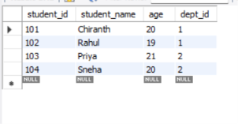

-- QUERY 1: BASIC PROCEDURE
DELIMITER //

CREATE PROCEDURE DisplayStudents()
BEGIN
SELECT * FROM Student;
END //

DELIMITER ;

-- EXECUTE PROCEDURE
CALL DisplayStudents();
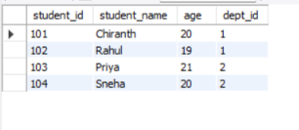

-- QUERY 2: INSERT PROCEDURE
DELIMITER //

CREATE PROCEDURE InsertStudent(
IN sid INT,
IN sname VARCHAR(50),
IN sage INT,
IN did INT
)
BEGIN
INSERT INTO Student
VALUES (sid, sname, sage, did);
END //

DELIMITER ;

-- EXECUTE INSERT PROCEDURE
CALL InsertStudent(105, 'Arjun', 22, 1);

-- DISPLAY INSERTED RECORD
SELECT * FROM Student;
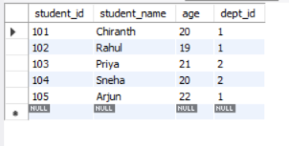

-- QUERY 3: UPDATE PROCEDURE
DELIMITER //

CREATE PROCEDURE UpdateStudent(
IN sid INT,
IN new_age INT
)
BEGIN
UPDATE Student
SET age = new_age
WHERE student_id = sid;
END //

DELIMITER ;

-- EXECUTE UPDATE PROCEDURE
CALL UpdateStudent(105, 23);

-- DISPLAY UPDATED RECORD
SELECT * FROM Student
WHERE student_id = 105;

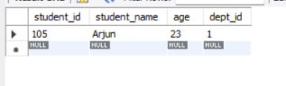
-- QUERY 4: DELETE PROCEDURE
DELIMITER //

CREATE PROCEDURE DeleteStudent(
IN sid INT
)
BEGIN
DELETE FROM Student
WHERE student_id = sid;
END //

DELIMITER ;
-- EXECUTE DELETE PROCEDURE
CALL DeleteStudent(105);
-- DISPLAY FINAL TABLE
SELECT * FROM Student;


